Spring and springboot

Interview Question:
“What is the Saga Pattern?”
I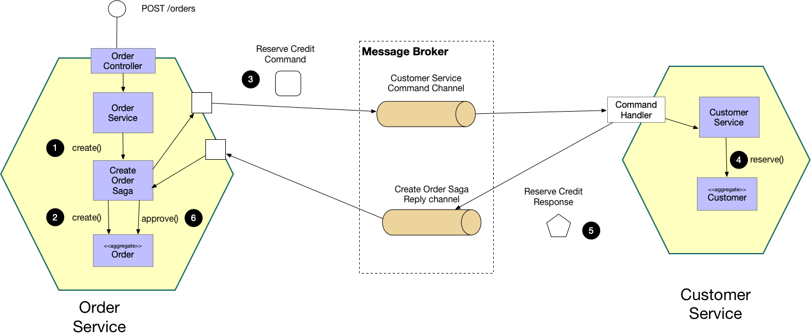
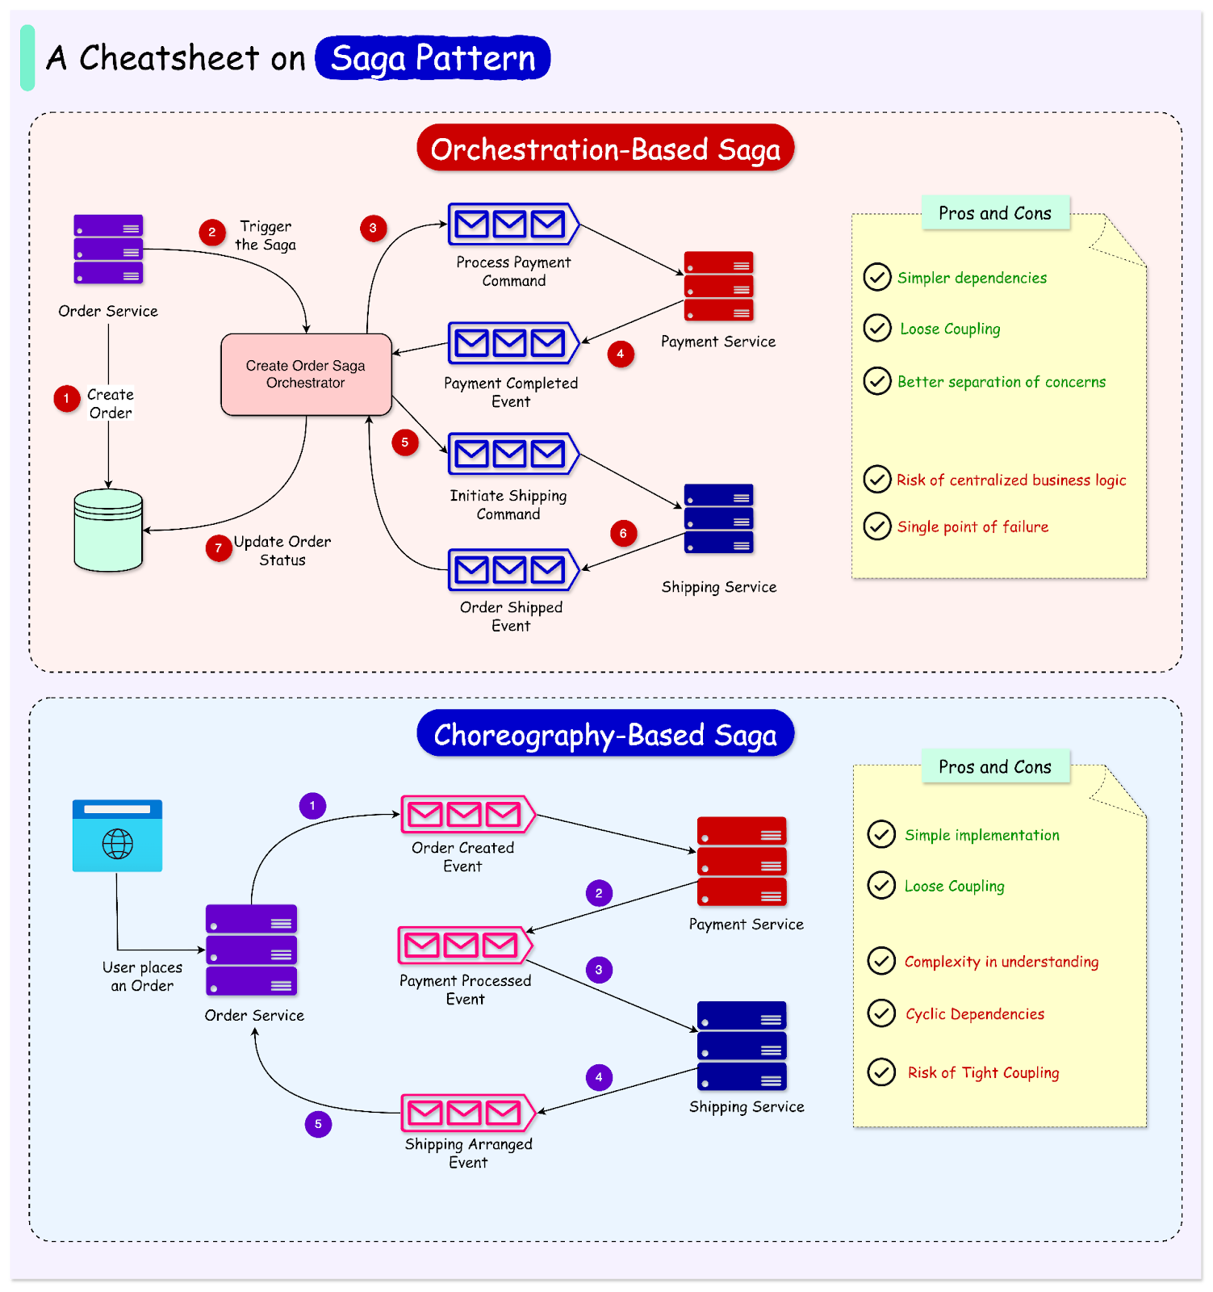

Strong Answer:
The Saga Pattern is used in microservices to manage distributed transactions across multiple services without using a single database transaction.
Instead of one global transaction, a saga consists of a sequence of local transactions. Each service performs its operation and publishes an event or response.
If any step fails, compensating transactions are triggered to undo the previous successful steps, ensuring eventual consistency.

Why Saga Pattern Is Needed
In microservices, each service has its own database, so traditional ACID transactions are not possible. Saga pattern helps maintain consistency in such cases.

Types of Saga Pattern

1. Choreography Saga
- No central controller
- Services communicate via events
- Each service decides the next action
Interview line:
Choreography-based saga is event-driven and loosely coupled.

2. Orchestration Saga
- Central Saga Orchestrator manages flow
- Orchestrator tells services what to do next
Interview line:
Orchestration-based saga provides better control and visibility of the transaction flow.

Real-World Example (You Can Say This):
For example, in an order processing system, placing an order, making payment, and updating inventory are separate services. If payment fails, the order creation is rolled back using a compensating transaction.

One-Line Version (Super Crisp):
Saga Pattern manages distributed transactions in microservices using local transactions and compensating actions.

Key Keywords to Mention
- Distributed transactions
- Eventual consistency
- Compensating transactions
- Choreography vs Orchestration
- Microservices databases

Bonus (Spring Boot Context):
Saga Pattern is often implemented using event-driven tools like Kafka or with an orchestrator service in Spring Boot microservices.

“How is a login system implemented in Spring Boot?”

Strong Answer:
Spring Boot provides a login system using Spring Security, which handles authentication and authorization.
In a typical Spring Boot application, user credentials are authenticated using Username and Password Authentication. Spring Security validates the credentials against a database, in-memory users, or an external identity provider.
For modern applications, especially microservices, we implement a JWT-based login system, where a token is generated after successful login and used for securing subsequent API requests.

Login Options Available in Spring Boot

1. Form-Based Login
Uses a default or custom login page provided by Spring Security.
Used mainly in: Traditional web applications

